**Spring Boot – DevTools**

Spring Boot provides DevTools, a module designed to ease your development process, it improves the experience of developing applications resulting in optimizing the developer’s productivity for building exceptional software.

It aims to reduce development time, by intelligently detecting code changes to auto-recompile your code reducing the need to manually restart your application.

Spring Boot DevTools offers many other development-time features listed below, one among them is explained above as auto-recompilation of code:

* Property DefaultstoAutomatic Restart
* Live Reload
* Global Settings
* Remote Debug Tunneling

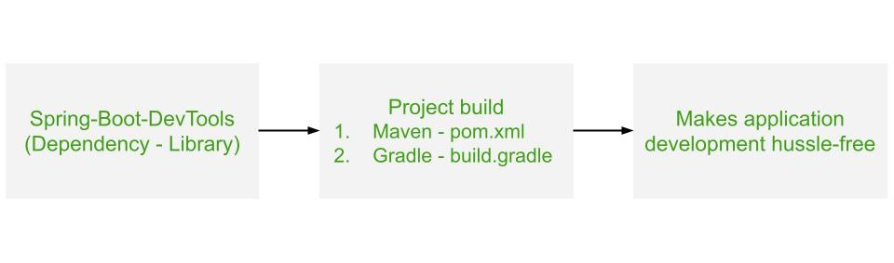

*Working of Spring Boot – DevTools*

**Note:** It is important to understand that the ‘DevTools’ is not an IDE plugin, nor does it require that you should use a specific IDE.

**1. DevTools Configuration in Spring Boot**

There are a few configurations required to use DevTools in your Spring Boot Application

**1.1 Spring Boot Devtools Dependency**

For Maven build automation tools dependency is-

*<!--Maven pom.xml-->*

**<dependency>**

**<groupId>**org.springframework.boot**</groupId>**

**<artifactId>**spring-boot-devtools**</artifactId>**

**<scope>**runtime**</scope>**

**</dependency>**

For Gradle build automation tools dependency is-

dependencies { compile("**org.springframework.boot:spring-boot-devtools**") }   
OR   
dependencies { developmentOnly("**org.springframework.boot:spring-boot-devtools**") }

**1.2 Application Properties Settings for Spring Boot DevTools**

Some configurations are available for application properties files to use Spring Boot DevTools.

**1.2.1 Toggle DevTools**

It can be used to customize the detection of classpath changes to trigger auto restart if your Spring Boot Application

**spring.devtools.restart.enabled**=true

**1.2.2 Exclude Resources from DevTools**

It can be used to specify certain resources that will excluded to trigger a restart of your Spring Boot Application.

**spring.devtools.restart.exclude**=resources/**,web-inf/**

for the above code ‘resources’ and ‘web-inf’ resources are excluded

**1.2.3 Enable/Disable LiveReloader for DevTools**

To customize the use of LiveReloader use this configuration

**spring.devtools.livereload.enabled**=true/false